19.11.21
LS: Tell the time ‘o’ clock, half past and quarter past.
Write the times shown on these clocks. ‘o’ clock half past quarter past quarter to
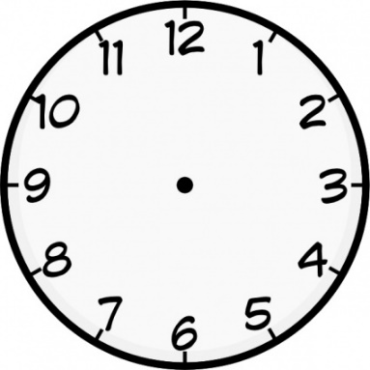

On these clocks draw the following times:

Twenty minutes past 8 Quarter to 12 Ten minutes past 7

Twenty-five minutes past 1 Half past 10 Quarter to 7

Quarter past 12 Quarter to 4 Five minutes past 6

