Year 2 Maths Tasks – Thursday 9th July 2020 Answers

Today we will continue to work on our topic of number sequences.

Parents: The children learnt about number sequences during the Autumn Term and it has been revisited throughout our time up until school closure. The children should remember that they need to look carefully at the numbers in the sequence to decide if the numbers are getting larger or smaller.

If the numbers are getting larger they should be able to look at see how much they change and get larger from one term of the sequence to the next. If the numbers are getting smaller the children should be able to identify how much smaller they are getting from one term to the next. Once they have then checked they are correct with the next few terms of the number sequence, the children should be able to find missing numbers from a sequence.

For example:
0, 5, 10, 15, 20, 25, 30, __, __
What is happening to the numbers? They are getting larger. How much are they getting larger by in each next number of the sequence? They are increasing by 5. They are the multiples of the 5 times table, they are going up by 5 for each new term of the sequence. To find the next two terms of the sequence add 5 to the last number 30 + 5= 35 then add 5 to this number to find the number after this 35 + 5= 40.

__, __, 30, 25, 20, 15, 10, 5, 0
What is happening to the numbers? They are getting smaller. How much are they getting smaller by in each next number of the sequence? They are decreasing by 5. They are the multiples of the 5 times table, they are going down by 5 for each new term of the sequence. If we need to find the first two terms of the sequence we need to start with the number 30 and subtract 5 to get 25, then repeat this and subtract 5 to find 20.

3, 5, 7, 9, 11, 13, 15, ___, ___
What is happening to the numbers? They are getting larger. How much are they getting larger by in each next number of the sequence? They are increasing by 2. They are starting at 3 and then going up by 2 for each new term of the sequence. To find the next two terms of the sequence add 2 to the last number 15 + 2= 17 then add 2 to this number to find the number after this 17 + 2= 19.

90, 80, 70, 60, 50, 40, ___, ___
What is happening to the numbers? They are getting smaller. How much are they getting smaller by in each next number of the sequence? They are decreasing by 10. They are the multiples of the 10 times table, they are going down by 10 for each new term of the sequence. If we take 10 from the last number in the sequence it gives us 30, then take 10 again and it gives us 20.

Children: Read through the examples of number sequences with your parents. Remember that a number sequence is a list of numbers which have a pattern from one number to the next. When you look at each number sequence think to yourself:

What is happening to the numbers? Are they getting smaller or larger?
How much are the numbers getting smaller or larger?
Check you are correct by looking at each number in the sequence and applying the rule (+3 or -5).
Where are the missing numbers?
How could you find the missing numbers? (e.g. Do you need to work backwards to find the missing numbers or do you need to apply the rule to find the missing numbers?)

- Mental maths activities
Please go online and work on the following activities:
*Number sequences
http://ictgames.com/rangeArranger/ You will need to choose how much the number sequence changes by 2, 5 or 10 and then select a sensible top number (e.g. if a 2 number sequence you would have a top number of 30, if a number sequence of 5 you might have a top number of 75).
*Daily 10 game- fractions
https://www.topmarks.co.uk/maths-games/daily10
*Children at school- complete the number sequence activity provided then you can have a go at the above mental maths game online at home.

- Number sequences
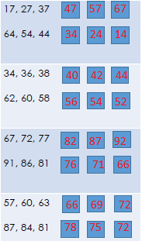
- Number Sequence Problem Solving

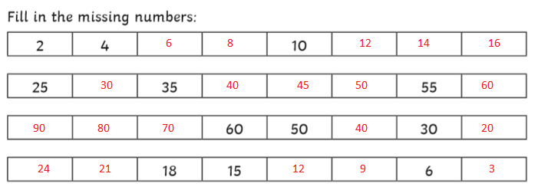
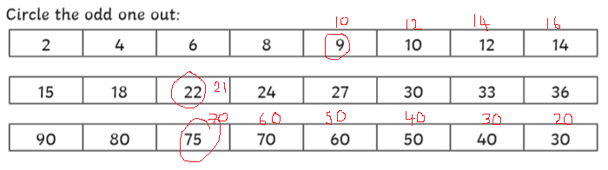
What should the odd number out be to make the number sequence correct?

