Year 2 Maths Tasks – Monday 6th July 2020

We will continue to work on our topic of mass and capacity this week, before moving on to number sequences.

Parents: Volume is the amount of liquid and is measured in millilitres and litres (1000 ml). When completing the scale activities your child will need to look at the way the scale increases. First of all they should look at the amounts labelled on the scales to work out how much the volume is going up on the scale. Then it is important to look at how many smaller lines are in between these amounts to be able to work out if they are going up in 1ml, 2ml, 5ml or 10ml.

Children: When we look at liquids and how much of a liquid we have we measure what is called the volume. The amount of liquid is measured in millilitres (ml is the short way of writing this). When we have 1000 ml we have a litre (l is the short way of writing this).

Look carefully at the measuring container and see if you can find the volumes of the amounts of liquid.

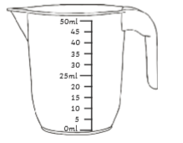 This jug has a scale of 5ml for each line on the scale.

This scale has lines which are worth 5 millilitres (this is what ml means on the scale). They go up in 5 millilitres all the way to 50 millilitres.

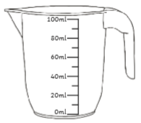 This jug has a scale of 20ml for each line on the scale.
This scale has lines which are worth 20 millilitres (this is what ml means on the scale). They go up in 20 millilitres all the way to 100 millilitres.

- Mental maths activities
Please go online and work on the following activities:
*Mostly postie game- matching the weight of the postcards to their measurement on the weighing scales
https://www.ictgames.com/mobilePage/mostlyPostie/index.html
answers in steps of 100g as well as answers in steps of 50g as a challenge
*Daily 10 game- fractions to revisit last week’s work
https://www.topmarks.co.uk/maths-games/daily10

- Capacity Investigation
Investigate different containers and their capacity. Predict which you think will hold the most and least volume of water and explain why. Then use a measuring jug to measure how much water each jug or container holds.

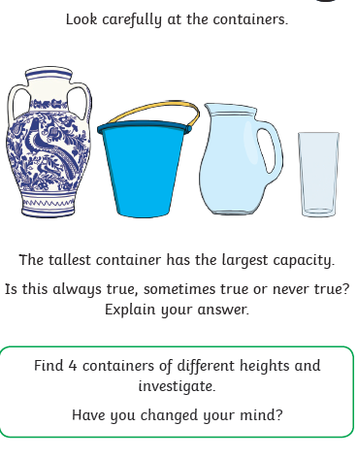

- Fill the jugs below with the correct volume of water. Remember to look carefully at the scales and think about the value of each line in between the labelled lines on the scale. Are they 1ml? 2ml? 5ml? 10ml? Or another volume of ml?

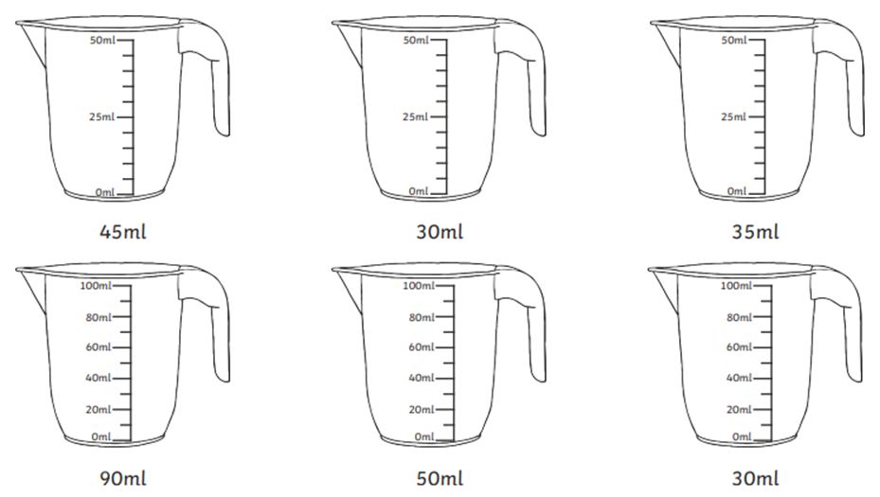

- Complete the following measurement problems.
