Year 4 Maths Tasks – Thursday 9th July 2020

Parents and Children: Today we are going to revise lots of the fraction tasks we have completed since lockdown.

Task 1
Complete these calculations – I have completed the first two as examples for you. Remember, the denominators (bottom numbers) stay the same and you complete the calculation for the numerator. Leave your number as a fraction or improper fraction. Do not convert them into mixed numbers.
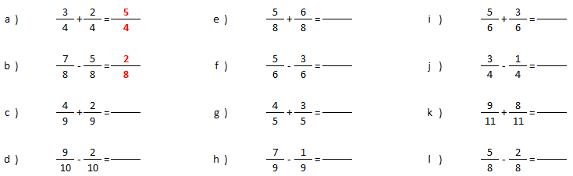

Task 2
Using the grids, colour the fractions and then complete the calculation. Write your final answer as a mixed number. I have completed the first question for you.
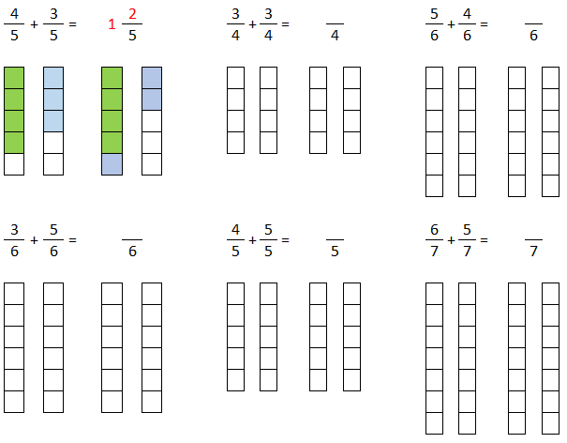

Please turn over for the next task

Task 3
In task 2 you created mixed numbers by using fraction sticks to colour the fractions. Now try to convert the improper fraction into a mixed number without the grid. If you need to draw, you can of course draw your own fraction sticks.

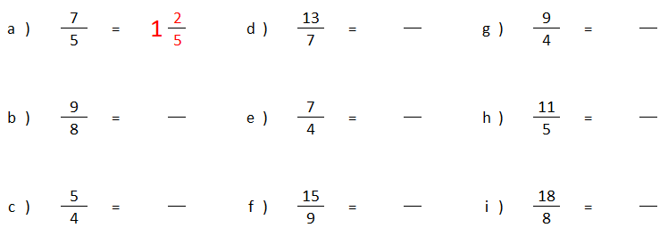

Task 4
Now that you can convert from improper to mixed, we need to revise the opposite – going from mixed to improper. As you do this, keep in mind what the fraction is telling you. For letter a), I know I have 1 whole (which is equivalent to 5/5) and as I have 2/5 as well, I must have 7/5 in total. The other way to look at this conversion is: denominator X whole + numerator = 5 x 1 + 2.

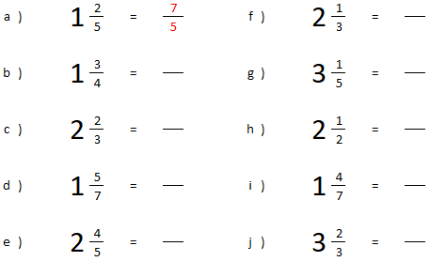
Task 5
To calculate the fraction of an amount, you need to divide the whole by the denominator (bottom) and then multiply that answer by the numerator (top). If it helps, use pasta or bricks to physically make the amounts and then you’ll be able to count the groups.

