Year 4 Maths Tasks – Thursday 2nd July 2020
ANSWERS
Parents and Children: Today we shall spend some time revising the work we completed on area and perimeter.

Task 1
Calculate the area and perimeter for each shape. I have used this template before but I have changed all of the numbers to give you new calculations. Don’t forget to put what type of measurement is being used (cm, mm, km etc) or to ‘square’ your area answers.
Area Perimeter
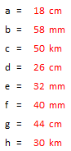
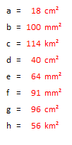
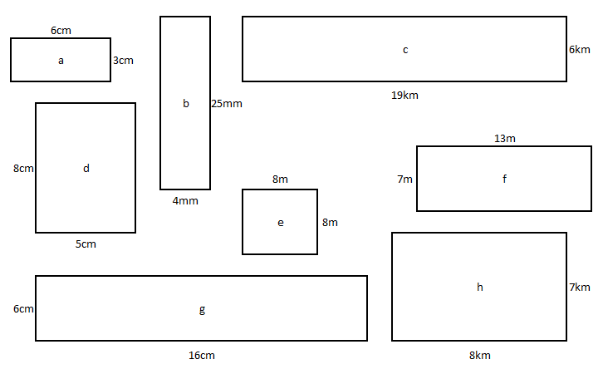

Task 2
What are the perimeters of the following shapes?
 | Detail | Perimeter
1 | An equilateral triangle with a side of 7cm | 21cm
2 | An isosceles triangle with a long side of 10cm and a short side of 3cm. | 23cm
3 | A regular pentagon with a side of 9m. | 45m
4 | A square with a side of 8cm. | 32cm
5 | A rectangle with a long side of 16m and a short side that is half the length of the long side. | 48m
6 | A regular hexagon with a side of 5km. | 30km

Task 3
Solve these problems using your perimeter and area skills. You might find it useful to draw the problems to help you visualise what is bring described.
- A farmer has to buy new fencing for his field that costs £5 per metre. If his field is rectangular and 10m long by 4m wide, how much will the new fencing cost in total? £140
- To sow seeds in his field costs the farmer £2 per square metre. How much does it cost to sow seeds in the entire field? £80
- The field next to the farmer’s field is available for sale. It is the same length but much wider. It is 7m. The new field costs £10 per square metre to buy. How much does it cost? £700
- The farmer decides to join his two fields together into one huge field and fence his new super field in electric fencing. The new fence costs £4 per half-metre. How much is the total cost of the farmer’s new fence. £336

