Year 3 Maths Tasks – Tuesday 7th July 2020

Parents and Children: Hello everyone. I hope you enjoyed the money and graphs work yesterday. Today we take that a little further to test your secure understanding of measurement using money.

All of the questions are solvable using the skills you have learned this year.

A
£2.80p + _____ = £10
£35.50p + _____ = £50
£6.73p + _____ = £15.20p
45p + _____ = £12.50p
£6.76p + _____ = £40

B
I bought a new game for my X Box.
It cost between £9 and £10.
I paid with a £10 note.
I received 4 silver coins as my change.
How much could the game have cost if all the silver coins were the same?
How many different answers could there be?

C
I buy my lunch and my friend’s lunch.
I buy two teas for 90p each; 2 sandwiches for £1.25p each and 2 yogurts for 55p each.
How much change will I get from a £10 note?
My friend says she can pay me half now and half tomorrow. How much will she have to pay me tomorrow?

D
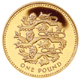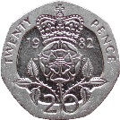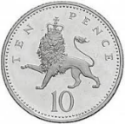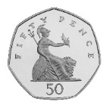

I pay for my lunch with these 4 coins.
How much was my lunch?
Show me three other ways I could have paid that amount for lunch.

E
Tom and Andy have saved £45 between them.
Tom has saved £11 more than Andy.
How much had each one saved?
Nita and India have saved £67 between them. Nita has saved £17 more than India.
How much has each one saved?

F
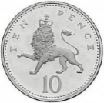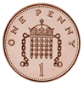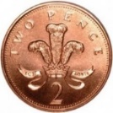

Place these five coins in a row following these instructions:
The total of the first three coins is 31p
The total of the last three coins is £1.12p
The last coin is double the value of the first coin.
Now make up some more instructions with these 5 coins and then with a different set of 5 coins.

G
I bought another new game for my X Box.
It cost between £15 and £20.
I paid with a £20 note.
I received 4 silver coins as my change.
How much could the game have cost if all the silver coins were different?
How much could the game have cost if all the coins were the same?

