Year 3 Maths Tasks – Monday 6th July 2020 -ANSWERS

Parents and Children: Hello everyone I hope you all had a good weekend. There are now only two more full weeks of home learning left before you can have a break and relax ready for a return to school in September (I realise that sentence is equally meaningful for parents as well as children). Well done all of you still with us!
As we don’t have too many lessons left, from now on I intend to provide questions on a whole range of the units we have covered this year.
All of the questions are solvable using the skills you have learned this year.

Let us start with some money questions.

A Answer the addition and subtraction questions below

50p + 20p
£1.50 + 25p
£2.50 – 60p
£3.25 – 75p

70p £1.75 £1.90 £2.50

B Answer these 2 step questions.

4 x 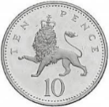 + 6 x 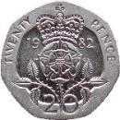 = £1.60 6 x 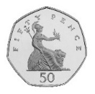 + 10 x 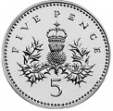 = £3.50

C Now try these questions.
a If I have 7 x 50p, how much have I got? £3.50

b If I have 8 x 20p, how much have I got? £1.60

c I pay with a £5 note for goods to the value of £3.15.
How much change should I receive? £1.85

d I pay with a £10 for goods to the value of £4.80p. How much change should I receive? £5.20

e Using coins make the following amounts in three different ways: Answers will vary
£5.75 5x£1, 50p, 20p & 5p 2x£2, £1, 7x10p & 5p 5x£1, 3x20p, 10p & 5p
£8.25 8x£1, 20p & 5p 4x£2, 2x10p & 5p £2, 6x£1, 10p & 3x5p
£11.90 11x£1, 50p, 2x20p 5x£2, £1, 9x10p 2x£2, 7x£1, 50p 3x10p & 2x5p
£15.67 2x£2, 11x£1, 50p, 10p, 5p & 2p 7x£2, £1, 6x10p, 5p & 2p 15x£1, 50p 3x5p & 2p
£5.98 2x£2, 1x£1, 50p, 4x10p, 5p, 2p & 1p £2, 3x£1, 9x10p, 5p, 2p & 1p 5x£1, 50p 8x5p & 4x2p

f If I pay with a £5 note for items that cost below, how much change should I receive?
£2.89 £4.12 89p £3.65 £2.90 75p
£2.11 88p £4.11 £1.35 £2.10 £4.25
What if I had used a £10 note to pay, how much change would I have received then?
£7.11 £5.88 £9.11 £6.35 £7.10 £9.25

D Pay the following amounts using the least amount of notes and coins.
£3.35 (5) £2, £1, 20p, 10p & 5p
£6.98 (8) £5 note, £1, 50p, 2x20p, 5p, 2p & 1p
£5.17 (4) £5 note, 10p, 5p, 2p
£2.78 (6) £2, 50p, 20p, 5p, 2p & 1p
99p (6) 50p, 2x20p, 5p & 2x2p
£6.76 (6) £5 note, £1, 50p, 20p, 5p & 1p

Now try these graphs questions

E The bar graph shows how children travel to school.

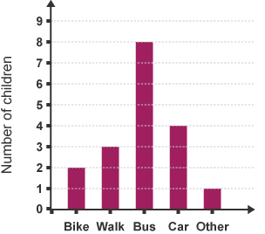

a How do most children get to school? By Bus

b Do more people walk or come on a bike? More people walk than come by bike

F A class was asked where they like picnicking. They had 3 choices.

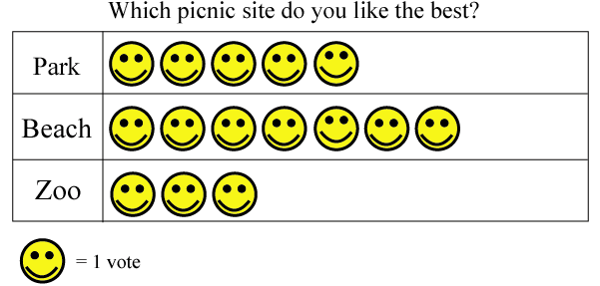

a Which was the favourite destination for a picnic? Beach

b How many more preferred the park to the zoo? 2 people

