Year 5 Maths Tasks – Tuesday 9th June 2020 ANSWERS

Birmingham 06:23 06:53 07:23 07:53
Coleshill 06:35 07:05 07:35 08:05
Nuneaton 07:00 07:22 07:51 08:22
Hinckley - 07:29 07:58 08:29
Leicester 07:17 07:48 08:17 08:48

Look at the train timetable above and then answer the questions.
- What time does the train that leaves Coleshill at 07:05 arrive at Hinckley? 07.29

- If I miss the 07:22 from Nuneaton to Leicester, which train could I catch next? The 07.51 train

- Which train from Birmingham doesn’t stop at Hinckley? (Give the time that it leaves Birmingham). 06.23

- I live in Coleshill and need to get to work in Leicester by 8 o’clock every morning. What is the latest train that I can get? 07.05

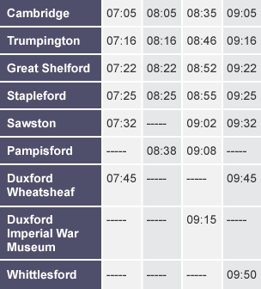
Look at the Cambridgeshire train timetable above, and answer the questions.
- What time does the only train to go to the War Museum, leave Cambridge? 08.35

- How long does it take to get from Cambridge to the War Museum? 40 minutes

- At what time does the 08.46 train from Trumpington arrive at Sawston? 09.02

- The train that arrives at 09:50 at Whittlesford left Great Shelford at what time? 09.22

Further task
Make a timetable of your day so far. You do not have to include every single thing that you did. You don’t have to use the exact times. Answers will vary – please check that they make sense and that the times are in order.

