Year 5 English Tasks –Friday 26th June

Hope you are all staying safe and hopefully some of you have managed to see some family members after such a long time apart. Fingers crossed the weather will pick up again this week and outside will not look so miserable.

Parents and children: This week we are focusing on a YouTube clip called Pigeon Impossible – DO NOT watch the clip until the instructions ask you to. Today we will be planning the monologue from the pigeon’s point of view. Next week we will be writing it. You will be following the same structure as the example you looked at yesterday.
This is the link to the Pigeon Impossible clip. You may watch this as many times as you need to help you with this lesson.
Only watch up to 1 minute 30 seconds!!!!!
https://www.youtube.com/watch?v=jEjUAnPc2VA

Task 1 – planning a monologue from the pigeon’s point of view
Paragraph 1:
Setting the scene
Paragraph 2:
Identifies food source
Paragraph 3:
Makes a plan to get the food source
Paragraph 4:
Does the Pigeon succeed in getting the food? What happens next?

Task 2: Planning ideas for monologue from pigeon’s point of view. Remember to take ideas from the example to guide you along.

Task 3 – Handwriting practice.
Remember to use the Newlands handwriting letter formations to ensure accurate handwriting. In school we would be completing a handwriting task every week, therefore, let’s keep up the practice.
Copy the following extract from Holes by Louis Sachar correctly. This text would have been our class text for the summer term. If you get the chance, it’s worth a read. When writing refer back to the guidelines if you have forgotten (see below).
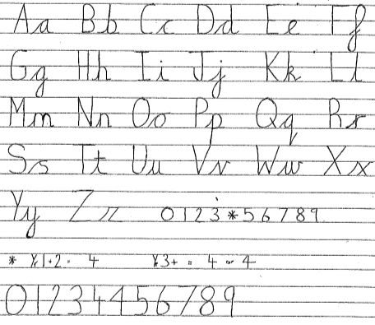
Check your ascenders and descenders are correct. Have you remembered which letters you join and which you don’t?
Over hundred and ten years ago, Green Lake was the largest lake in Texas. It was full of clear cool water, and it sparkled like a giant emerald in the sun. It was especially beautiful in the spring, when the peach trees, which lined the shore, bloomed with pink and rose-coloured blossoms.
There was always a town picnic on the Fourth of July. They’d play games, dance, sing and swim in the lake to keep cool Prizes were awarded for the best peach pie and peach jam.

Once you have written the above – Challenge – why did they celebrate on 4th July with a town picnic?

