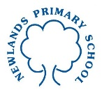
Year 2 Maths Tasks – Tuesday 30th June 2020

We will carry on from yesterday working on reading scales and finding the mass of objects before then moving on to volume.

Parents: Mass of an object is the amount of matter the object contains. The greater the mass the heavier the object is. The lesser the mass the lighter the object is. Weight is the mass of an object exerted on by the gravity of the Earth giving rise to a downward force. Although the children do not need to understand in this amount of detail, they do need to understand what mass is and how we measure it in units such as grams and kilograms.

Light mass Heavy mass

In the activity today the children will be looking at scales to measure mass. They would be best looking at the scale first and working out what each of the markings represents (50 grams or 100 grams) and then looking at where the needle on each scale is to read the mass in grams or kilograms.

When hunting for items as part of the investigation you could ask children, for items that do not have their weight on them, whether they think they would be measured in grams or kilograms. Ideally you could use kitchen scales for children to get some experience of items which weigh up to 1000 grams (1 kilogram), such a bag of sugar, to help children to get some context about what a kilogram is like as a mass.

Children: Mass is the amount of matter inside an object. If an item has a large mass it has a lot of matter inside it which means that it is heavy. If an item has less matter inside it the mass is smaller and it is lighter.

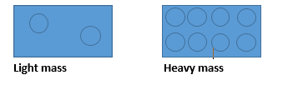
We measure mass in grams if something is light. When an object reaches 1000 grams we say that it weighs a kilogram. So light items are measured in grams and heavier items are measured in kilograms. Often we use measuring scales to measure the mass of objects.

To find the mass of an object in grams or kilograms look carefully at the scale.
Is each section worth 100g? Is each section worth 50g? Then see where the needle of the scale has reached to read the mass.

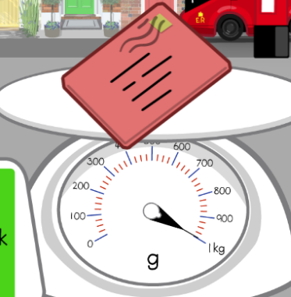
This scale has large blue lines which are worth 100 grams (this is what g means on the scale). They go up in 100 grams all the way to 1000 grams which is a kilogram (1 kg). The little red lines represent 25g because there are four sections on the red scale in between each 100 gram. The needle here points to 1 kg which is 1 kilogram. So the letter weighs 1 kilogram.

- Mental maths activities
Please go online and work on the following activities:
*Mostly postie game- matching the weight of the postcards to their measurement on the weighing scales
https://www.ictgames.com/mobilePage/mostlyPostie/index.html
answers in steps of 100g as well as answers in steps of 50g as a challenge
*Daily 10 game- fractions to revisit last week’s work
https://www.topmarks.co.uk/maths-games/daily10

- Problem solving scales
When you weigh the mass of items on scales they can do one of three things as shown below. Can you work out what each of these scales is showing? Can you take the items below and draw them on the scales to show which are equal mass, which are heavier than another, which are lighter than another? Can you get all of the combinations?

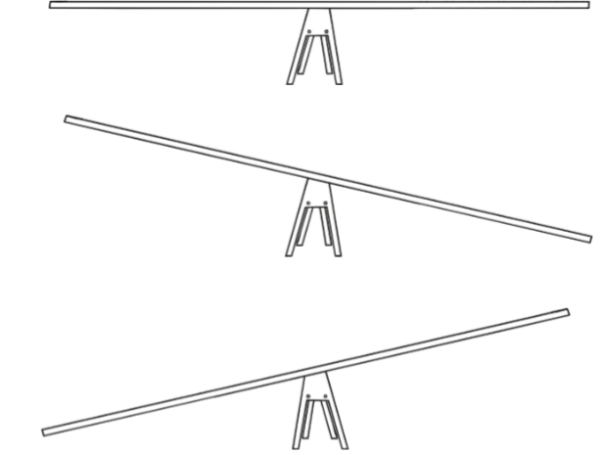

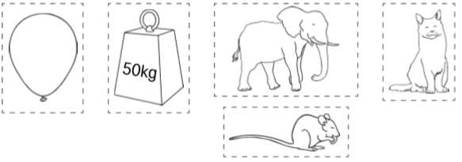
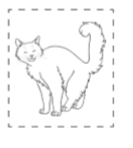

- Mass investigation
When you found the items around your house yesterday you recorded them in the diagram below. Can you use these to create your own scales like the ones above?

