Year 2 Maths Tasks – Tuesday 23rd June 2020 Answers

Well done for the lovely mathematics work people have sent in! I’m so impressed with how well you are using the strategies to help you! We will continue to work on fractions today.

Parents and children: To find a fraction of an amount the two different numbers the numerator (the top number of the fraction) and the denominator (the bottom number of the fraction) are very important.

1 numerator the numerator shows how many of those equal parts we are looking at

2 denominator the denominator shows how many equal parts the whole amount is shared into

In ½ we share the whole amount into 2 equal groups. We only want 1 out of the 2 equal groups when we find the fraction.

To find fractions of an amount first start with the amount of items or draw out the amount in the whole. Then draw circles to represent the denominator (the number of equal groups). Then share the total amount into the equal groups.

For example 1/3 of 6

0 0 0 0 0 0 – 6 the whole amount

The circles represent each of the 3 equal groups. One of these circles represents the 1/3- it is 1 out of the 3 equal groups.

If you are finding 2/4 then first find ¼ using the technique above, then add ¼ to another ¼ to make 2/4.
For example: Find 2/4 of 8

00000000 – 8 the whole amount

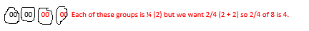
The circles represent each of the 4 equal groups. One of these circles represents the ¼. So to find 2/4 we want 2 out of the 4 equal groups.

- Mental maths activities
Please go online and work on the following activities:
*Fractions game- complete the fractions activity
https://resources.hwb.wales.gov.uk/VTC/ngfl/ngfl-flash/fractions/fractions.html
*Hit the Button- division facts for 2x, 5x and 10x
*Hit the Button- halves up to 20

- Mental maths activity- find the fraction of each of these. If it helps, children could use diagrams or objects to help them to find fractions.
a) ½ of 20 10
b) 1/3 0f 18 6
c) ½ of 18 9
d) 1/3 of 21 7
e) ¼ of 16 4
f) 1/3 of 12 4

- Look at the objects in the pictures below.
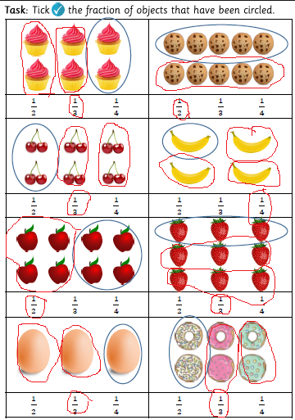

To find the fractions look at how many are in each group. Group the remaining objects in the same groups.

For example

Here two circles are grouped into a fraction. There are two in this fraction.

- 000000

We now need to group the remaining circles into equal groups of 2, which means that when we have done this that there are four equal groups. So the amount circled was 1 out of the 4 equal groups= ¼.
(00) (00) (00) (00)

- Investigation

How many different equivalent fractions can you find using the fractions wall?

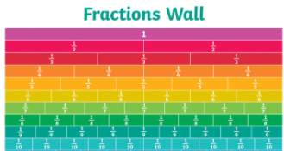

1= 2/2, 1=3/3, 1= 4/4, 1= 5/5, 1= 6/6, 1= 7/7, 1= 8/8, 1= 9/9, 1= 10/10
½= 2/4, ½= 3/6, ½= 4/8, ½= 5/10
1/3= 2/6, 1/3= 3/9
¼= 2/8

