Year 2 English Tasks – Monday 28th June 2020 Answers

Parents: As explained below the children need to write out their different types of sentences using the spellings provided. Please encourage your child to explain the type of sentence they have used for each spelling word as verbalising it will help your child to remember the different types of sentence.

Children:

Think about the different types of sentence we have learned to use this year.

Statements- these are sentences with a capital letter and a full stop. They include information in the sentence.
e.g. Mrs Furzland taught Oak Class.

Exclamation- these sentences emphasise information in them. They start with a capital letter and finish with an exclamation mark.
e.g. What a fantastic effort with your home learning!

Question- these sentences ask a question and always begin with a question word and end with a question mark.
e.g. What is your favourite colour?

Command- these sentences begin with an imperative verb (a doing word) which tells you to do something and end with a full stop.
e.g. Put your dirty socks in the laundry basket.

- Spellings activity
Write a statement, exclamation, question or command for the following spellings. You can choose which type of sentence you use for each spelling.

Gold
Old
Hold
Told
Water
Grass
Pass

Keep your gold in the safe because it will keep it safe. Command
How old is your brother? Question
Hold the pencil carefully. Command
I like to drink water. Statement
That grass is incredibly green! Exclamation
Would you like a Summer Pass for Legoland? Question

- Reading comprehension
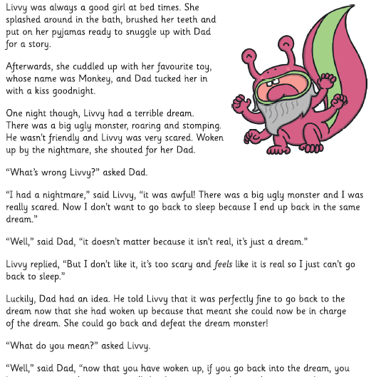

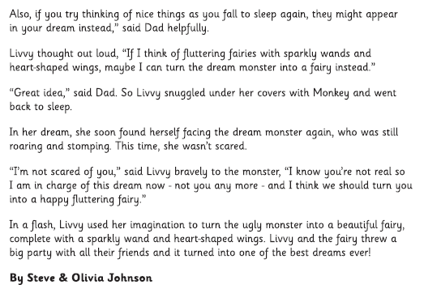
With each question look for the key word or phrase to find in the passage above. Skim to find the key word or phrase (or a similar word or phrase) then scan the sentence carefully (read the sentence in detail) to find an answer. Or find a clue that might help you to answer the question.

a) What was the name of Livvy’s favourite toy? Monkey
b) Why did Livvy wake up and shout to her Dad? She was having a nightmare about a monster.
c) Find the two words that describe what the Monster looked like in Livvy’s dream. Big and ugly are used to describe the monster.
d) What was the Monster like? How do you know? He was an unfriendly monster because he was roaring and stomping at Livvy.
e) Why did Livvy not want to go back to sleep? Livvy didn’t want to go to sleep because she was worried that she might end up seeing the monster again or being upset by it.
f) How did Dad say that Livvy would know that the Monster wasn’t real? When Livvy goes back to sleep she would know it was unreal because she could use her imagination to pretend that it was something else that Livvy liked.
g) What did Livvy dream of when she went back to sleep? Livvy dreamed of a fairy with a sparkly wand and heart-shaped wings. She dreamed that they had a party with all of their friends.

- Picture activity

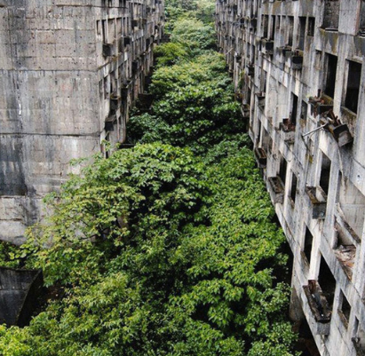
Look at the picture above. Write down any questions you have about the picture or the place. Talk to your Mum or Dad about what you think the answers might be in detail. Write down a conclusion about what you think the picture shows, what has happened and why. I would love to hear your ideas!

Why is no-one in the picture?
Why are there buildings covered in plants or trees?
Why are the trees and plants everywhere?
What happened to the buildings?
Does anyone live in the buildings?
Why are there broken parts of the buildings?
Why do the buildings look so grey and bleak?
Are the plants growing all through the buildings?
Can people get into the buildings?
What might have happened for the plants to grow so much in and around the buildings?

