Year 4 Maths Tasks – Friday 26th June 2020

Parents and Children: I hope you have enjoyed the mixture of activities I have planned this week. Have a wonderful weekend.

Task 1
Ideally, I’d like you to complete two columns but as it is Friday, I’d accept only 1!
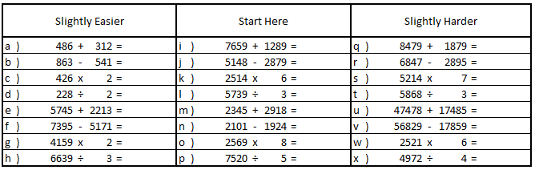

Task 2
Partition the first number in each calculation for questions i – n. I have done i as an example for you.
- 7659 = 7000, 600, 50, 9

Task 3
Complete both of the 10-minute times tables tests (they are on the website). When you have finished, identify which tables you need to revise next week if you have not scored over 140 in each test. Being able to score 140+ in both tests will be a huge help to you next year and beyond. Keep working hard on your tables – I know you’ll get there if you aren’t already!

Task 4
Back in May we spent some time revising how to calculate the fraction of an amount. Complete these problems.
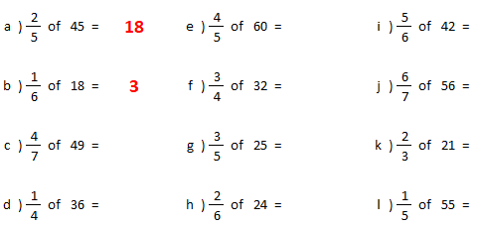

Well done for working so hard this week. I am very proud of you all!

