Year 4 English Tasks – Monday 22nd June 2020

Parents and Children: Good morning Maple Class. I hope you have had a lovely weekend and are ready to work hard today – I hope you enjoy what I’ve planned! I think by now you will have guessed that I love a silly story. I also enjoy reading stories and poems that rhyme or performance poetry that has a beat or actions. To start this week, we are going to work with a poem by Joseph Coelho. I was lucky enough to attend a course where he led a session on performing poetry – it was amazing! This is a link to his website: https://www.thepoetryofjosephcoelho.com/portfolio_page/a-little-bit-of-food-2/ On it, there are videos of him performing his own work but you must promise to not watch (or read) the rest of Hamster! Hamster! if you go on there – we’ll finish the poem tomorrow. Children – get permission before you go on the internet.

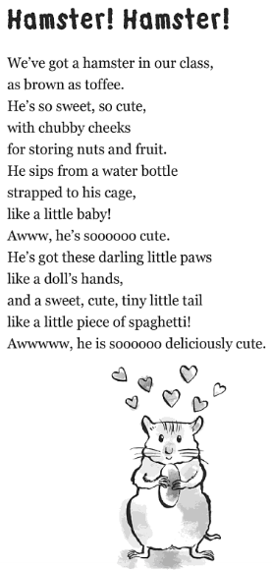
Task 1
Read the poem several times and make sure you can pronounce each work accurately. Once you are confident, think about how you would perform the poem if you had to read it aloud. Can you find the pulse or make the poem flow? How are you going to say ‘Awww,’ or ‘soooooo’? Do you need to put a voice on or read it normally? Notice that the second ‘Awwwww’ is longer. Why do you think that is? Does it change how you say it? Hearing yourself reading something is the best way to perfect your performance, so if you can, record yourself and then think about how to improve your performance.

Task 2
Think about what we have learned about apostrophes. What are the uncontracted versions of these words?

We’ve = __________ he’s = __________

What is the apostrophe doing in the line about the dolls?

Task 3
How many adjectives describe the hamster’s tail and what are they?

Task 4
What is the preposition in the first line?

Task 5
Today, I’d like you to write a poem about our school tortoise! We are going to use Hamster! Hamster! as a template. This means we’ll use the structure and layout and only change the details to fit our tortoise. My example is underneath the illustration of the hamster.
Read it carefully and you’ll be able to see I am using a lot of the original poem and just tweaking details to make it suit the tortoise. You can be more creative than me, but try to follow the structure (you do need to think it is cute!). When you have finished your poem, check your copying is accurate for what you have borrowed and that your spelling for your own ideas is as good as it can be. Keep your poem safe – you’ll need it tomorrow!

Task 6 (Optional)
Rehearse and perform your tortoise poem like you did for task 1. You could illustrate it too if you’d enjoy doing that!

Tortoise! Tortoise!
We’ve got a tortoise in our school,
as green as the trees on the field.
He’s so sweet, so cute,
with scaly cheeks
for munching flowers.

