Year 6 Maths Tasks – Thursday 2nd April 2020
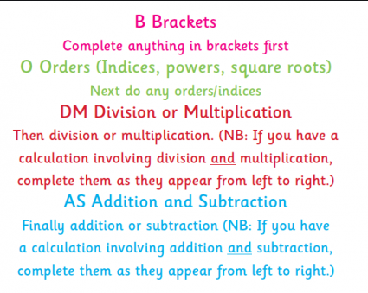

Today’s maths is using BODMAS and the order of the operations.

Parents: Encourage the children to write out BODMAS so that they can refer to it while completing the calculations.

Children: Work through the BODMAS questions methodically. Check the operations that the calculation contains and rewrite it at each step so you know what the ‘new’ calculation looks like. Remember that the answer to each step becomes the next part of the calculation.

- 5 x (12 – 3) = | f) 2³ + 2 = | k) 100 + 4² ÷ 2 =
- 4 + 5 x 2 = | g) (4+2) x 12 = | l) 30 + 15 x 2 =
- 14 ÷ 7 + 3 = | h) 90 ÷ 10 x 10 = | m) 200 + 2 x 6 =
- 4 + 2 x 3 = | i) 18 ÷ (10 – 1) = | n) 725 – 25 ÷ 5 =
- 3 x (6² + 3) = | j) (3² + 2) x 5 – 3 = | o) 5² x 2 + 3 =

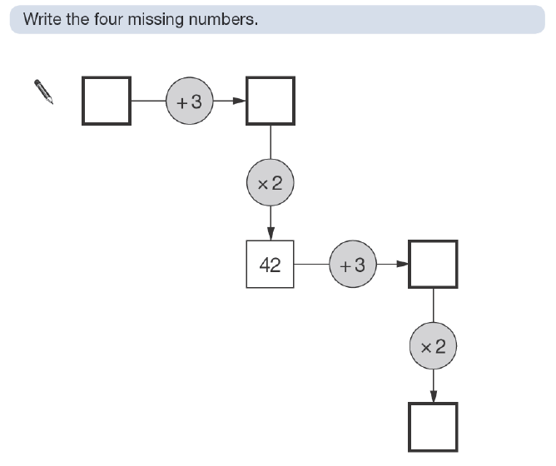
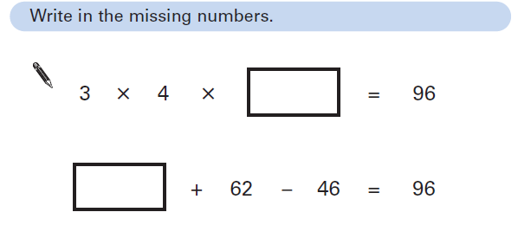

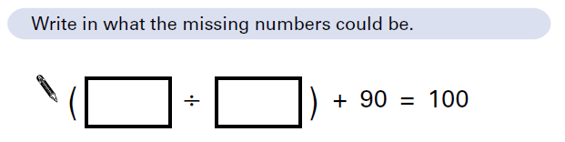

Further Tasks: Complete a mixed and grid times tables test. Set a timer and see how fast you can do it AND get them all right.

